

Stay at Le Meridien New Delhi

Is now a veritable masterpiece. Done up in the international Art & Tech style where the best hotels across the world are switching to. Every element is coordinated so that it is a symphony for all your senses.

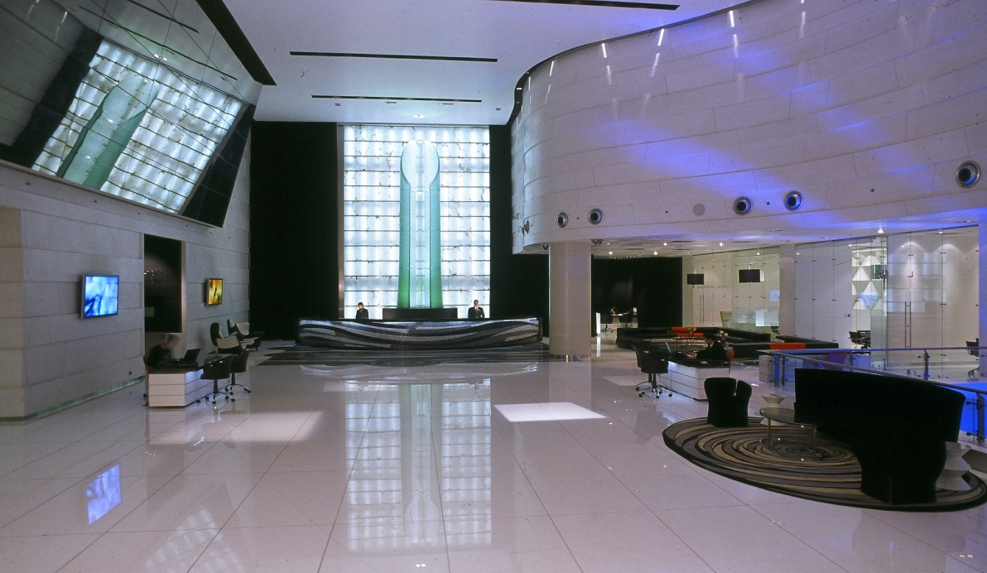

Le Meridien New Delhi is offering a special accommodation package, exclusively for the guests arriving for the All India Prosecutors Association (AIPA).11th – 14th March 2026

Located at Windsor Place, Janpath, in the heart of the city and within a 2km radius of major central Government Offices, the Parliament House, the Presidential Palace (Rashtrapati Bhawan), the bustling Commercial and fashionable shopping district of Connaught Place, Pragati Maidan, the venue of Trade Exhibitions and Fairs and popular historical and cultural landmarks of the city.

For booking details, please refer to the
Reservation Form on the reverse.


Windsor Place, Janpath, New Delhi-India
Tel.: 91(011) 2371 0101
Website: www.lemeridien.com



RESERVATION FORM

⁬ New Reservation ⁬ Amendment ⁬ Cancellation

NAME OF GUEST (Mr. / Ms.):
(First): (last/family name):

E Mail -

NAME OF THE COMPANY:
DEPARTURE DATE:
FLIGHT: ETA: TRANSFER*: YES/NO
ARRIVAL DATE:
FLIGHT: ETA: TRANSFER*: YES/NO

TYPE OF ROOM:
Executive Room

Room Rate per Room per night
INR 15,000.00 plus taxes single
INR 16,000.00 plus taxes double

.

Special Request: Smoking ( ) Non Smoking ( )

Credit Card Guarantee
Credit Card No.:
Expiry Date:
Card Type:

Name:
Tel. No.:
Fax No.:
Date:
E Mail:

- Rates are exclusive of all applicable taxes. Taxes applicable are 18% GST. In case of any changes in the taxes the same shall be applicable extra.
- Executive room :Rate is Inclusive of buffet breakfast and WIFI ( shared bandwidth )
- Our Check In time is 1500 hrs and checkout time is 1200 hrs. Early check in or check out cannot be guaranteed, and is subject to availability at the time of arrival, unless the room is pre-registered from the night before.
- Please advise us of any special requirement such as baby cot (free), extra bed (INR 2000 exclusive of taxes per night), and rooms on the same floor, adjoining rooms or connected rooms. The hotel will endeavor to fulfill your request. However these cannot be guaranteed prior to arrival.
- All reservations must be guaranteed by a credit card. Any reservation not guaranteed with the credit card shall not be accepted.
- This reservation will only be held until 72 hours prior to the day of arrival if not guaranteed by a credit card.
- Cancellation / amendment can be advised to the hotel by 1st July 2025 after which entire stay will be charged on the credit card number provided.
- These rooms are subject to availability on receipt of reservation request latest by 1st December 2025. After this any reservation received would be on the best available rate of the day and subject to room availability.

Note: Airport pick-up or Drop can be arranged via Toyota Innova at INR 4725/- per car per way if not included in room rate .

Kindly direct all reservations to Rajesh Sikka via email:
rsikka@lemeridien-newdelhi.com
Windsor Place, Janpath, New Delhi-India, Tel.:91(011)2371 0101

