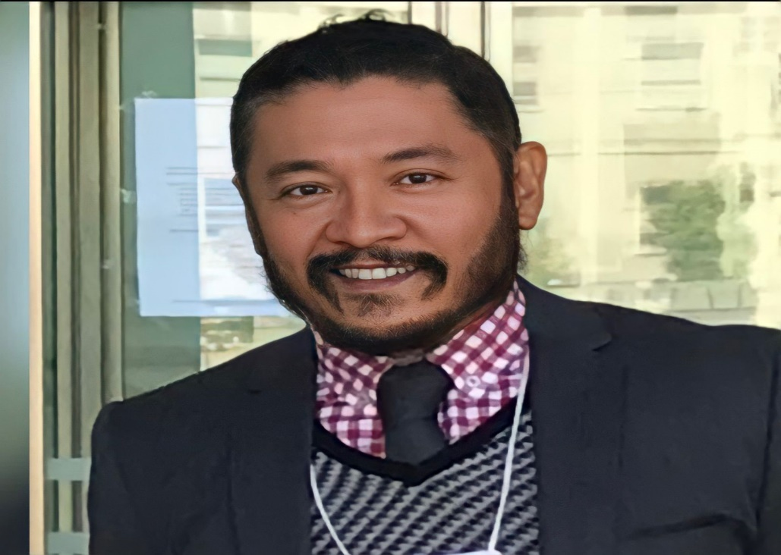

**Cássius Guimarães Chai**

Associate Law Professor Under and Graduate Programs – Universidade Federal do Maranhão – Brazil

Culture, Law, and Society Research Group Chair (DGP/CNPq/UFMA)

Law Professor Faculdade de Direito de Vitória (FDV) – Brazil

Visiting Researcher Beijing Criminal College – G20 Research Center – China

Researcher at the Instituto de Saúde Pública – Universidade do Porto – Portugal

Criminal Prosecutor after 1997 – MPMA

Internal Affairs General Attorney’s Office

[cassiuschai@gmail.com](mailto:cassiuschai@gmail.com)