**BIO OF ANDRE GLITZ**

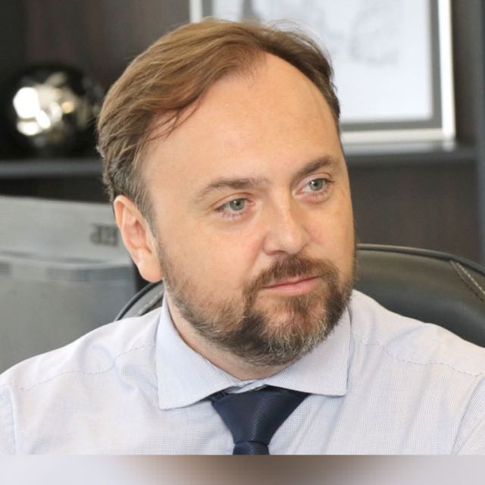

* Prosecutor of the Public Ministry of the State of Paraná - Brazil.
* President of the Paraná Association of the Public Ministry.
* Coordinator of the CONAMP Legislative Propositions Commission.
* Master of Laws (LL.M) from Columbia Law School (Nova York, EUA).
* Professor at the School Foundation of the Public Ministry of the State of Paraná (FEMPAR).